**Choosing Appropriate Statistical Analyses**

**DVs: Number of Trips and Visitors**

##Matrix Correlation observation:

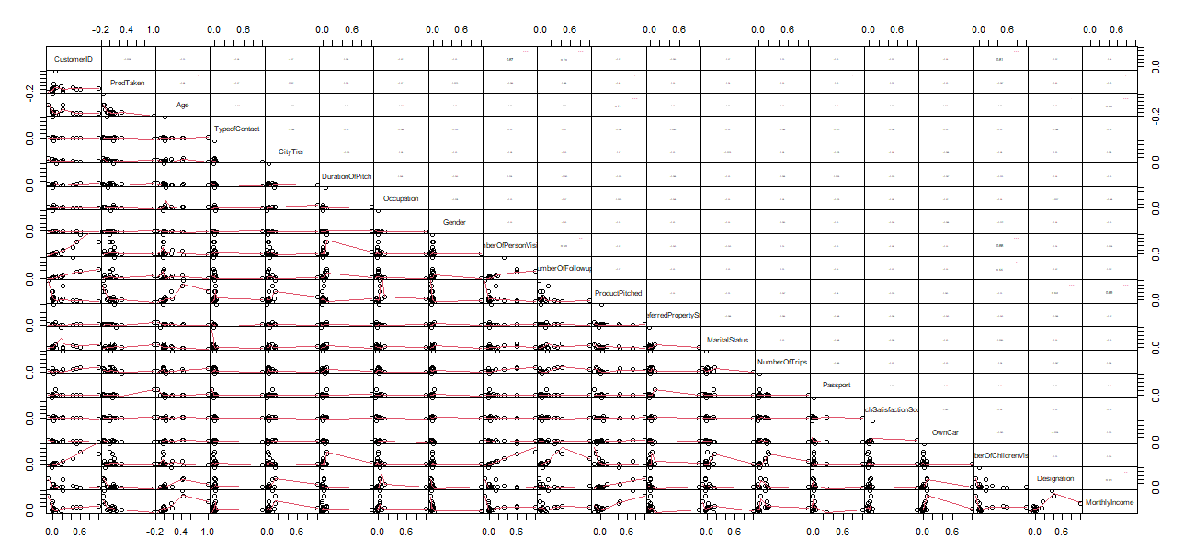

Correlation with customer who bought a product and make under 10 trips

Correlation with all customers.

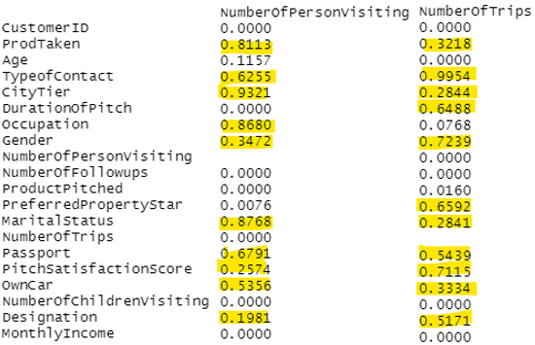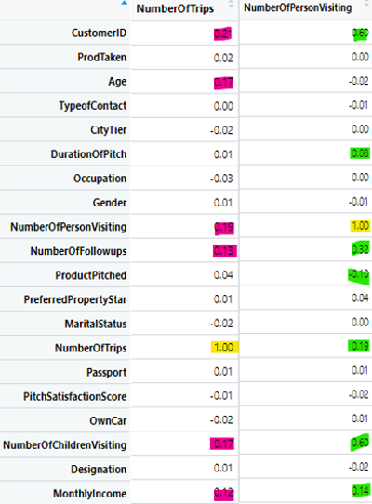

* As we can see, the correlation in the original dataset is very week since 80% of our customer base did not make a purchase.
* Therefore, we would more likely gather more realistic information on customers who are interesting in our product if we only exam customers who actually made a purchase.
* In addition, most customer made under 10 trips. Therefore, we will also not exam those exceptions in our analysis.

According to our matrix table, there are variables that highly correlated with both of our DVs and few only correlated with one of our DVs. We will exam these correlations in details.

#DVs: NumberOfTrips and NumberOfPersonVisiting

Categorical IVs correlated with both DVs: - **MANOVA**

TypeofContact

CityTier

Gender

MaritalStatus

Passport

OwnCar

Designation   
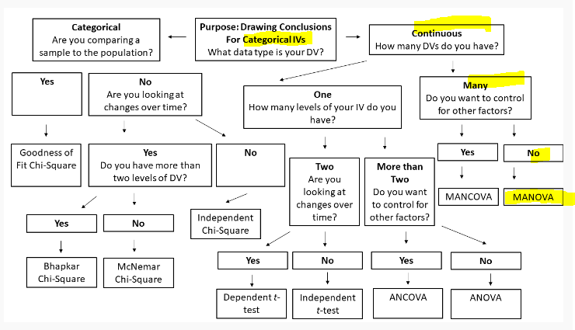

Continuous IVs correlated with both DVs:

PitchSatisfactionScore - or explore with just NumberOfTrips -> Simple Linear Regression.

Using Canonical Correlation Analysis in R

<https://cmdlinetips.com/2020/12/canonical-correlation-analysis-in-r/#:~:text=Canonical%20Correlation%20Analysis%20%28CCA%29%20with%20cancor%20%28%29%20function,the%20linear%20projection%20of%20the%20second%20data%20matrix>.

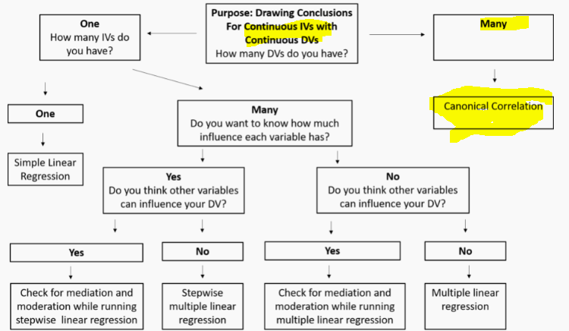

IVs correlated with NumberofTrips only:

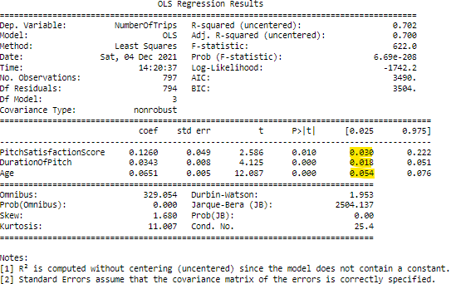

IVs correlated with NumberOfPersonVisiting only:

1. Occupation - ANCOVA

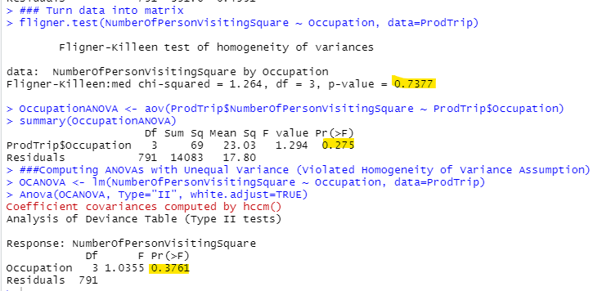

### The Numbers of Visistors per trip is not different among different Occupation.

Conclusion:

Exam variables means:

* Examing Type of Contact, Company is lower than **Self Enquiry**.
* 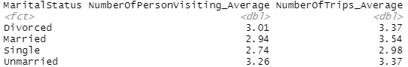**Married** clients makes the most trip with the most visitors.
* 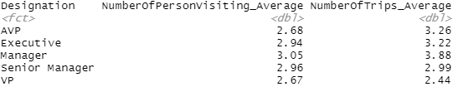**Manager Designation** has the highest number trips with the most visitors.
* 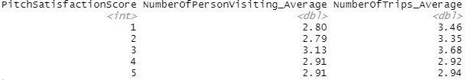Customers give satisfaction score of 3 makes the most trips.
* Customers with rating of 1 and 2 has the lowest number of visitors.
* Property star of 5 makes the most trip.
* 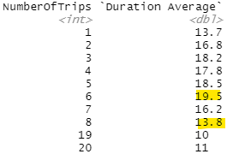Property star of 3 has lowest travelors.
* Customer receive Pitch Duration between 13 to 20 makes the most trips

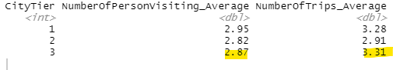

Among those who make a product, those who are self enquiry either unmarried or Married

|  |  |  |  |  |  |
| --- | --- | --- | --- | --- | --- |
| **Customer Taken Product** | | | | |  |
|  |  | **No. Visitors** | | **No. Trips** | |
| **TypeofContact** | 0.003 | 0.1449 |  | 0.01928 | Self Enquiry |
|  | Significant | Not Significant |  | Significant |
| **CityTier** | 0.04258 | 0.06442 |  | 0.1144 | 3 |
|  | Significant | Not Significant | 3 | Not Significant |
| **MaritalStatus** | 6.07E-11 | 1.69E-11 |  | 0.00528 |  |
|  | Significant | Significant | Unmarried | Significant | Married |
| **Designation** | 0.001557 | 0.1186 |  | 0.0002882 |  |
|  | Significant | Not Significant | Manager | Significant | Manager |
| **PitchSatisfactionScore** | 0.03 | Negative correlation | | | |
|  | Significant |
| **DurationOfPitch** | 0.018 | Negative correlation | | | |
|  | Significant |

**Target customer should be those who self enquiry with city Tier 3, either married or Unmarried, with low pitch duration and small satisfaction score by Manager Designation.**